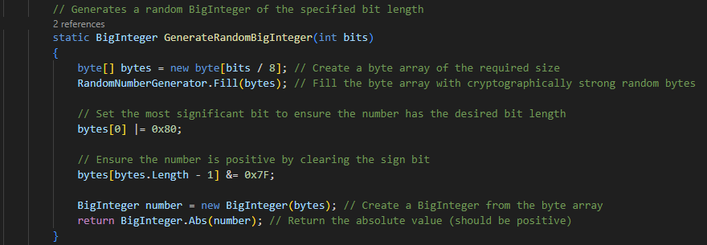

These 2 sections of code along with all the comments in the script were generated by ChatGPT.